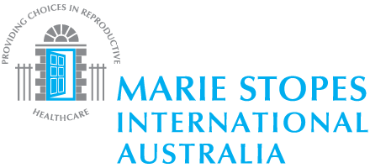
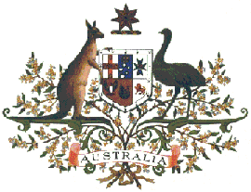

Australia advancing disability-inclusive development in Kenya

Media Release
4 March 2014

An Australian-funded scheme is saving and transforming lives in the Rift Valley, Nyanza, Eastern and Coast region in Kenya.

With funding from the Australian Government, NGOs have improved the health of more than 15,000 women and children through providing modern family planning methods, child vaccinations and safe and clean baby delivery services. Nearly 2000 farmers have also been assisted with fertiliser, seeds and improved access to agricultural extension services and advice.

H.E. Mr Geoff Tooth, Australia’s High Commissioner to Kenya, was delighted to hear of the findings of the Report. ‘I have visited AACES projects in my time as High Commissioner and it is inspiring to see how this report reflect our efforts to reach the poorest and most marginalised people in these communities.’

The Annual Report for the Australia Africa Community Engagement Scheme (AACES) shows how Australian Government support to NGOs is improving peoples’ lives and delivering more opportunities to the most vulnerable and poor, including people with a disability.

The program has been transformational for people such as Fatuma Katana aged 26, a mother of six living with disability. A health clinic supported by AACES was established in her community, providing counselling and low cost family planning options, allowing Fatuma to make an informed choice about when to have children as well as avoid unwanted pregnancy. Fatuma is overjoyed that for the next three years she will not have to borrow contraception from her neighbour. She is even happier to have received family planning information that she is now sharing with other women in the community, as well as her husband.
In Eastern Kenya marginalised communities have improved food security. This has been achieved through distribution of inputs such as seeds and fertilizer and support for Farmer Field Schools involving more than 1900 smallholder farmers, including people with disability. Alternative income-generating activities such as beekeeping, tree nurseries, weaving and hiring of tents and chairs, were offered to people with disability unable to farm.

The AACES program is being implemented in Kenya by ActionAid International Kenya, Mothers Union of the Anglican Church, World Vision Kenya, Plan International Kenya and Marie Stopes Kenya.

The AACES Annual Report is available at www.dfat.gov.au

Notes to Editors

About AACES
AACES is a partnership of the Australian Government, ten Australian Non-Governmental Organisations (NGOs) and their Africa-based partners. The $90 million program is funded by the Australian Government, through the Department of Foreign Affairs and Trade (DFAT).

The program focuses on marginalised communities, with particular attention to women, children, people with disability and people vulnerable to disaster. It is being implemented in 11 African countries: Ethiopia, Ghana, Kenya, Malawi, Mozambique, Rwanda, South Africa, Tanzania, Uganda, Zambia and Zimbabwe.

For further information contact:
Alice Oyaro, Program Manager, Civil Society, DFAT
Phone: +254 20 427 7272, Email: Alice.Oyaro@dfat.gov.au

Douglas Waudo, Communications Officer, AACES
Phone: +254 723 911 145, Email: d.waudo@acbf-pact.org

THE END.

